Internet Programming Lab
Experiments 41–47

Experiment 41: WanderNotes — Personal Travel Blog
Design a travel blog homepage with featured photos and an interactive map of visited destinations, individual blog posts organized by category, and a comment section for reader engagement.

Code
<!DOCTYPE html>
<html><head><meta charset="utf-8"><title>WanderNotes</title>
<style>
body{font-family:Segoe UI,Arial;margin:0;background:#fafaf7;color:#2b2b2b}
header{background:#264653;color:#fff;padding:20px 40px}
header h1{margin:0;font-size:24px}header p{margin:4px 0 0;font-size:13px;opacity:.9}
.map{margin:16px 40px;height:70px;background:repeating-linear-gradient(45deg,#e9f5f0,#e9f5f0 10px,#d7ede4 10px,#d7ede4 20px);border-radius:8px;display:flex;align-items:center;justify-content:center;font-size:12px;color:#2a9d8f}
.posts{display:flex;gap:14px;padding:0 40px 20px}
.p{flex:1;background:#fff;border-radius:8px;overflow:hidden;box-shadow:0 1px 4px #0002}
.p .img{height:80px}
.i1{background:#f4a261}.i2{background:#2a9d8f}.i3{background:#e76f51}
.p .body{padding:10px}
.p h4{margin:0 0 4px;font-size:13px}
.p span{font-size:11px;color:#888}
</style></head>
<body>
<header><h1>🌍 WanderNotes</h1><p>A travel blog documenting adventures around the world</p></header>
<div class="map">🗺 Interactive map — click a pin to open the destination's blog post</div>
<div class="posts">
<div class="p"><div class="img i1"></div><div class="body"><h4>Sunrise over Kodaikanal</h4><span>Destinations · 12 comments</span></div></div>
<div class="p"><div class="img i2"></div><div class="body"><h4>Street Food in Hanoi</h4><span>Food · 8 comments</span></div></div>
<div class="p"><div class="img i3"></div><div class="body"><h4>Packing for the Alps</h4><span>Travel Guides · 5 comments</span></div></div>
</div>
</body></html>

Output
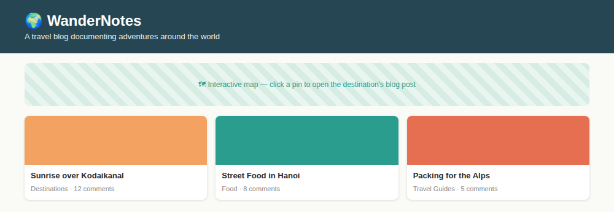

Experiment 42: RecipeNest — Digital Recipe Book Platform
Design a recipe platform with a curated homepage by cuisine/diet/difficulty, a search bar, and recipe pages with ingredients, step-by-step instructions, ratings and comments.

Code
<!DOCTYPE html>
<html><head><meta charset="utf-8"><title>RecipeNest</title>
<style>
body{font-family:Segoe UI,Arial;margin:0;background:#fff8f0;color:#2b2b2b}
header{background:#e07a5f;color:#fff;padding:20px 40px}
header h1{margin:0;font-size:24px}
.search{padding:14px 40px;display:flex;gap:10px}
.search input{flex:1;padding:9px;border:1px solid #ddd;border-radius:4px}
.search select{padding:9px;border:1px solid #ddd;border-radius:4px}
.recipes{display:flex;gap:14px;padding:0 40px 20px}
.r{flex:1;background:#fff;border-radius:8px;overflow:hidden;box-shadow:0 1px 4px #0002}
.r .img{height:80px}
.i1{background:#f2cc8f}.i2{background:#81b29a}.i3{background:#3d405b}
.r .body{padding:10px}
.r h4{margin:0 0 4px;font-size:13px}
.r span{font-size:11px;color:#888}
.stars{color:#e07a5f;font-size:12px}
</style></head>
<body>
<header><h1>🍳 RecipeNest</h1><p style="margin:4px 0 0;font-size:13px;opacity:.9">Discover, cook, and share recipes</p></header>
<div class="search"><input placeholder="Search recipes or ingredients..."><select><option>All Cuisines</option><option>Vegetarian</option><option>Dessert</option></select></div>
<div class="recipes">
<div class="r"><div class="img i1"></div><div class="body"><h4>Paneer Butter Masala</h4><span class="stars">★★★★☆</span><br><span>30 min · Medium</span></div></div>
<div class="r"><div class="img i2"></div><div class="body"><h4>Avocado Salad</h4><span class="stars">★★★★★</span><br><span>10 min · Easy</span></div></div>
<div class="r"><div class="img i3"></div><div class="body"><h4>Chocolate Lava Cake</h4><span class="stars">★★★★☆</span><br><span>25 min · Medium</span></div></div>
</div>
</body></html>

Output
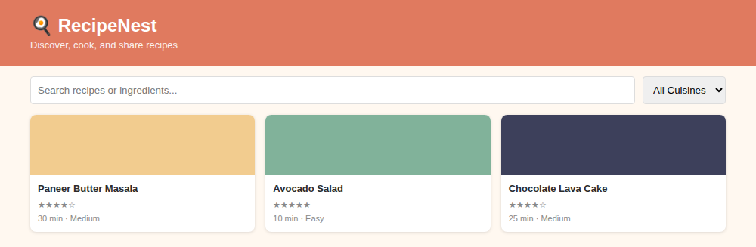

Experiment 43: ElectroPay — Online Electricity Bill Payment
Design an electricity bill payment dashboard showing current bill amount, due date and units consumed, with a payment-method selector and admin-side slab-based fine and tariff calculation.

Code
<!DOCTYPE html>
<html><head><meta charset="utf-8"><title>ElectroPay</title>
<style>
body{font-family:Segoe UI,Arial;margin:0;background:#f2f6fa;color:#222}
header{background:#023047;color:#fff;padding:18px 40px}
header h1{margin:0;font-size:22px}
.grid{display:flex;gap:14px;padding:20px 40px}
.card{flex:1;background:#fff;border-radius:8px;padding:14px;box-shadow:0 1px 4px #0002}
.card h4{margin:0;font-size:12px;color:#666}
.card .val{font-size:20px;font-weight:bold;color:#023047;margin-top:6px}
.pay{margin:0 40px 30px;background:#fff;border-radius:8px;padding:16px 20px;box-shadow:0 1px 4px #0002;display:flex;gap:10px}
.pay select{flex:1;padding:9px;border:1px solid #ddd;border-radius:4px}
.pay button{background:#fb8500;color:#fff;border:0;padding:9px 22px;border-radius:4px;font-weight:bold}
</style></head>
<body>
<header><h1>⚡ ElectroPay</h1><p style="margin:4px 0 0;font-size:13px;opacity:.9">Online Electricity Bill Payment</p></header>
<div class="grid">
<div class="card"><h4>Current Bill</h4><div class="val">₹1,240</div></div>
<div class="card"><h4>Due Date</h4><div class="val">05-Sep-2026</div></div>
<div class="card"><h4>Units Consumed</h4><div class="val">312 kWh</div></div>
</div>
<div class="pay"><select><option>Credit / Debit Card</option><option>Net Banking</option><option>Digital Wallet</option></select><button>Pay Now</button></div>
</body></html>

Output
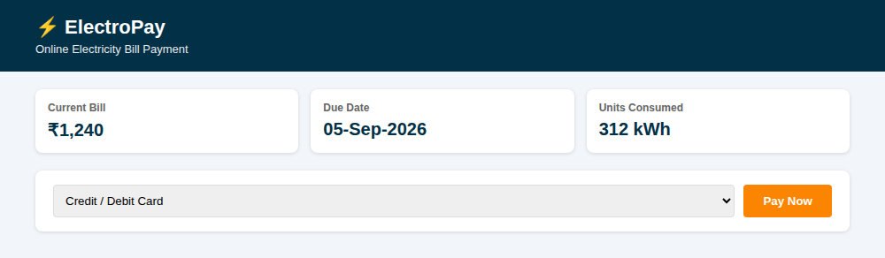

Experiment 44: ExamPortal — Online Placement Examination
Design an examination portal where candidates attempt a scheduled test that is auto-evaluated, and results are published as a ranked list with scores and a downloadable scorecard.

Code
<!DOCTYPE html>
<html><head><meta charset="utf-8"><title>ExamPortal</title>
<style>
body{font-family:Segoe UI,Arial;margin:0;background:#f5f7fb;color:#222}
header{background:#5f0f40;color:#fff;padding:18px 40px}
header h1{margin:0;font-size:22px}
.panel{margin:20px 40px;background:#fff;border-radius:8px;box-shadow:0 1px 4px #0002}
.panel h2{margin:0;padding:12px 18px;font-size:15px;border-bottom:1px solid #eee;background:#faf5f8}
table{width:100%;border-collapse:collapse;font-size:13px}
th,td{padding:9px 18px;text-align:left;border-bottom:1px solid #f0f0f0}
th{color:#666}
.rank{font-weight:bold;color:#5f0f40}
.btn{background:#5f0f40;color:#fff;border:0;padding:10px 22px;border-radius:5px;margin:0 40px 24px;display:inline-block}
</style></head>
<body>
<header><h1>📝 ExamPortal</h1><p style="margin:4px 0 0;font-size:13px;opacity:.9">Online Placement Examination</p></header>
<div class="panel">
<h2>Result — Aptitude Test 2026</h2>
<table>
<tr><th>Rank</th><th>Candidate</th><th>Score</th><th>Status</th></tr>
<tr><td class="rank">1</td><td>Ananya R.</td><td>92/100</td><td>Passed</td></tr>
<tr><td class="rank">2</td><td>Karthik S.</td><td>88/100</td><td>Passed</td></tr>
<tr><td class="rank">3</td><td>Divya M.</td><td>85/100</td><td>Passed</td></tr>
</table>
</div>
<div class="btn">Download Scorecard</div>
</body></html>

Output
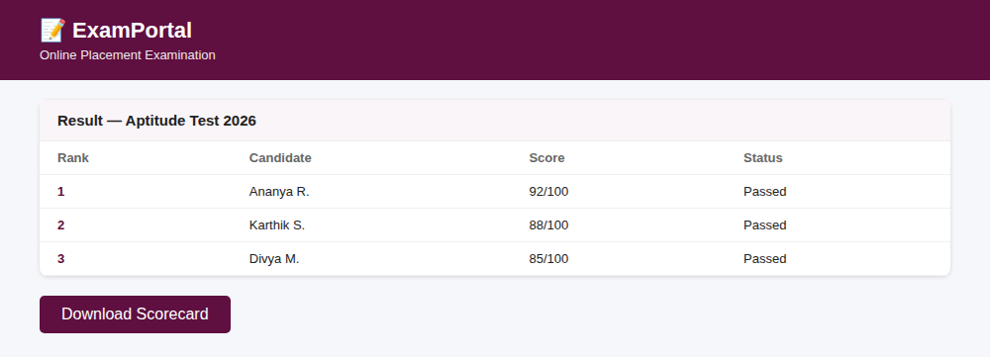

Experiment 45: ArtRate — Painting Rating & Review Platform
Design a painting display page where customers submit star ratings and written reviews, with a dynamically updated average rating and an admin summary of positive/negative feedback before rotating in a new painting.

Code
<!DOCTYPE html>
<html><head><meta charset="utf-8"><title>ArtRate</title>
<style>
body{font-family:Segoe UI,Arial;margin:0;background:#fbf9f6;color:#222}
header{background:#6d597a;color:#fff;padding:18px 40px}
header h1{margin:0;font-size:22px}
.wrap{display:flex;gap:20px;padding:20px 40px}
.art{width:200px;height:150px;background:linear-gradient(135deg,#b56576,#e56b6f);border-radius:8px}
.info{flex:1}
.info h3{margin:0 0 6px}
.stars{color:#f4a261;font-size:18px}
.rev{background:#fff;border-radius:6px;padding:10px;margin-top:8px;font-size:12px;box-shadow:0 1px 3px #0002}
.rev b{font-size:12px}
.summary{margin:0 40px 30px;background:#fff;border-radius:8px;padding:14px 18px;box-shadow:0 1px 4px #0002;font-size:13px}
</style></head>
<body>
<header><h1>🎨 ArtRate</h1><p style="margin:4px 0 0;font-size:13px;opacity:.9">Painting Display &amp; Review Platform</p></header>
<div class="wrap">
<div class="art"></div>
<div class="info">
<h3>"Whispering Dunes" — by R. Menon</h3>
<div class="stars">★★★★☆ <span style="color:#666;font-size:13px">(4.3 avg · 27 reviews)</span></div>
<div class="rev"><b>Priya:</b> "Beautiful use of color and texture."</div>
<div class="rev"><b>Arjun:</b> "Would love to see more from this series."</div>
</div>
</div>
<div class="summary"><b>Admin Summary:</b> 22 positive · 5 negative reviews — package expires in 4 days, next painting scheduled for rotation.</div>
</body></html>

Output
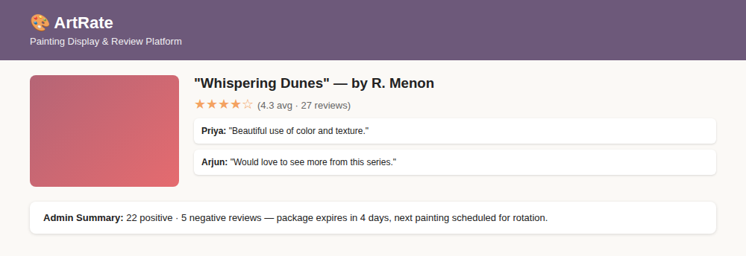

Experiment 46: TaxEase — Income Tax Calculator
Design an income-tax calculation page where an employee enters salary, HRA and deduction details, and the system computes net taxable income and a full tax-liability breakdown using slab rates.

Code
<!DOCTYPE html>
<html><head><meta charset="utf-8"><title>TaxEase</title>
<style>
body{font-family:Segoe UI,Arial;margin:0;background:#f4f7f5;color:#222}
header{background:#1b4332;color:#fff;padding:18px 40px}
header h1{margin:0;font-size:22px}
.form{display:flex;gap:14px;padding:20px 40px}
.f{flex:1;background:#fff;border-radius:8px;padding:14px;box-shadow:0 1px 4px #0002}
.f label{font-size:11px;color:#666;display:block;margin-bottom:4px}
.f input{width:90%;padding:8px;border:1px solid #ddd;border-radius:4px}
.result{margin:0 40px 30px;background:#e9f5ee;border-radius:8px;padding:16px 20px}
.result h3{margin:0 0 8px;font-size:14px;color:#1b4332}
.row{display:flex;justify-content:space-between;font-size:13px;padding:4px 0;border-bottom:1px dashed #cfe5d8}
.row b{color:#1b4332}
</style></head>
<body>
<header><h1>🧾 TaxEase</h1><p style="margin:4px 0 0;font-size:13px;opacity:.9">Income Tax Calculator</p></header>
<div class="form">
<div class="f"><label>Gross Annual Salary</label><input value="₹9,00,000"></div>
<div class="f"><label>HRA Received</label><input value="₹1,80,000"></div>
<div class="f"><label>Pension / Insurance</label><input value="₹60,000"></div>
</div>
<div class="result">
<h3>Tax Breakdown</h3>
<div class="row"><span>Net Taxable Income</span><b>₹6,10,000</b></div>
<div class="row"><span>Tax Slab Applied (5% + 20%)</span><b>₹22,000</b></div>
<div class="row"><span>Total Tax Liability</span><b>₹22,000</b></div>
<div class="row"><span>Net Income After Tax</span><b>₹5,88,000</b></div>
</div>
</body></html>

Output
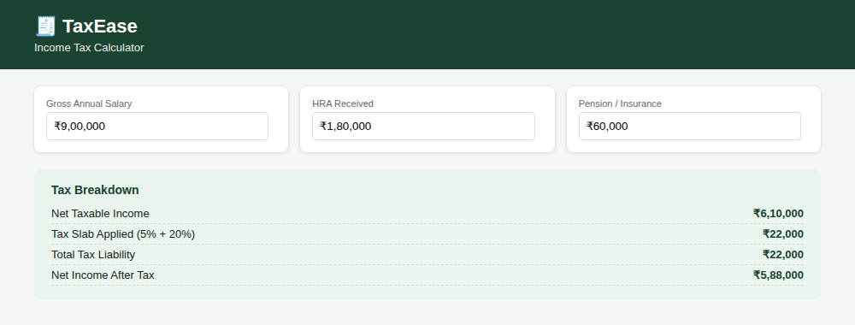

Experiment 47: PhonePay — Online Phone Bill Payment
Design a mobile bill payment dashboard showing outstanding amount, due date and current plan, letting the customer pay a full or custom amount via card/UPI/net banking, with auto-pay and reminder toggles.

Code
<!DOCTYPE html>
<html><head><meta charset="utf-8"><title>PhonePay</title>
<style>
body{font-family:Segoe UI,Arial;margin:0;background:#f3f0fb;color:#222}
header{background:#3a0ca3;color:#fff;padding:18px 40px}
header h1{margin:0;font-size:22px}
.grid{display:flex;gap:14px;padding:20px 40px}
.card{flex:1;background:#fff;border-radius:8px;padding:14px;box-shadow:0 1px 4px #0002}
.card h4{margin:0;font-size:12px;color:#666}
.card .val{font-size:20px;font-weight:bold;color:#3a0ca3;margin-top:6px}
.pay{margin:0 40px 16px;background:#fff;border-radius:8px;padding:16px 20px;box-shadow:0 1px 4px #0002;display:flex;gap:10px}
.pay input{flex:1;padding:9px;border:1px solid #ddd;border-radius:4px}
.pay select{padding:9px;border:1px solid #ddd;border-radius:4px}
.pay button{background:#7209b7;color:#fff;border:0;padding:9px 22px;border-radius:4px;font-weight:bold}
.toggle{margin:0 40px 30px;font-size:12px;color:#555}
</style></head>
<body>
<header><h1>📱 PhonePay</h1><p style="margin:4px 0 0;font-size:13px;opacity:.9">Online Mobile Bill Payment</p></header>
<div class="grid">
<div class="card"><h4>Outstanding Amount</h4><div class="val">₹649</div></div>
<div class="card"><h4>Due Date</h4><div class="val">10-Sep-2026</div></div>
<div class="card"><h4>Plan</h4><div class="val">Unlimited 5G</div></div>
</div>
<div class="pay"><input placeholder="Amount to Pay" value="₹649"><select><option>Credit Card</option><option>UPI</option><option>Net Banking</option></select><button>Pay Bill</button></div>
<div class="toggle">☑ Enable auto-pay for next month &nbsp;&nbsp; ☑ Send due-date reminders via SMS</div>
</body></html>

Output
